All log and exponential questions from 2025 to 2020 June

J2020/31

J2020/33
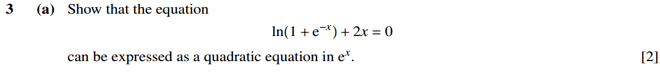

J2021/31/Q2
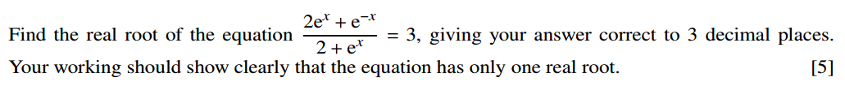

J2021/33

J2022/31/Q1

J2022/32

J2022/33

J2023/31
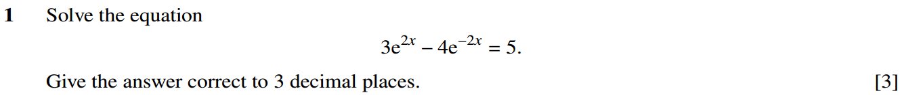

J2023/32

J2023/33

J2024/31

J2024/33

J2025/31

J2025/32

J2025/33

